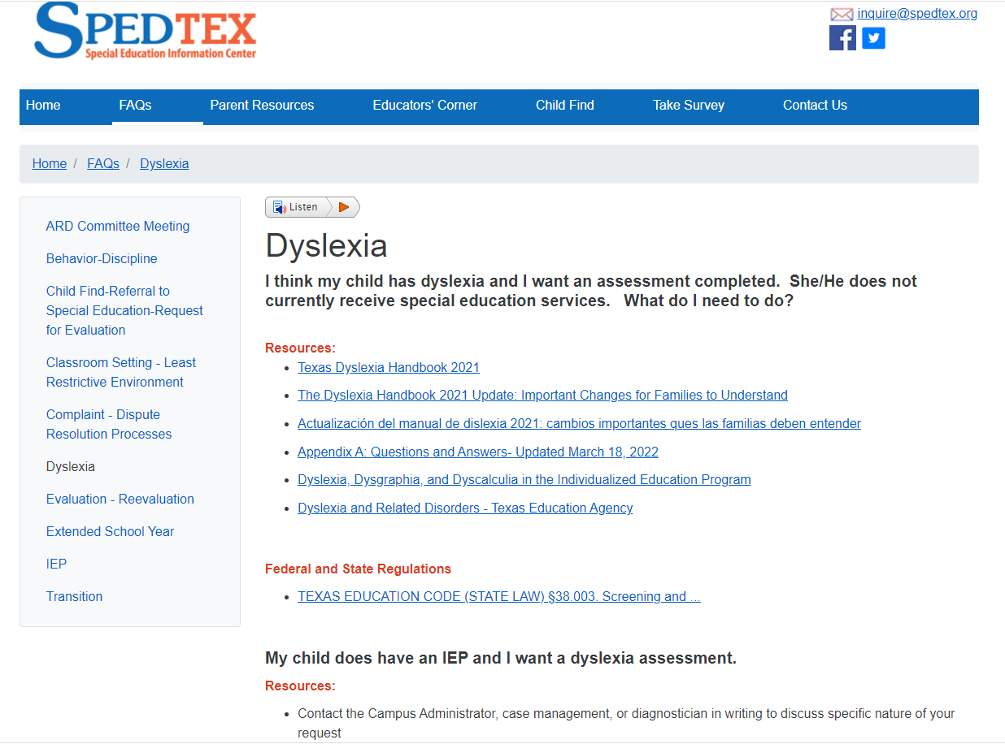

<https://www.spedtex.org/index.cfm/faqs/dyslexia>